- Write a steps in connecting Tableau to any excel and CSV file and provide screenshot for each and every step.
Ans:
- Step 1: Open Tableau Desktop
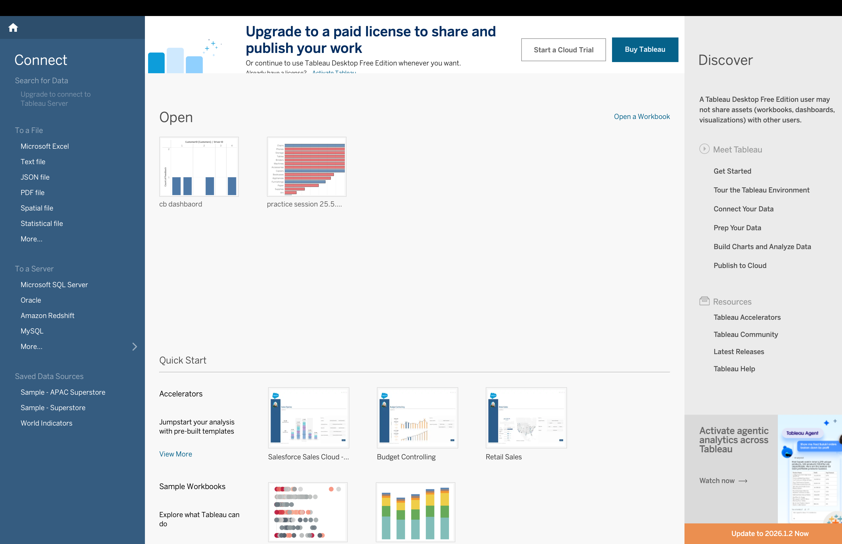
- Step 2: Select Microsoft Excel-> Browse and Select Excel File-> View Data Source Page
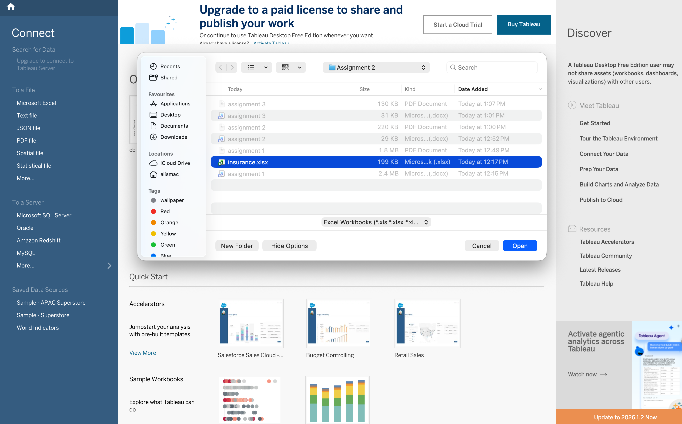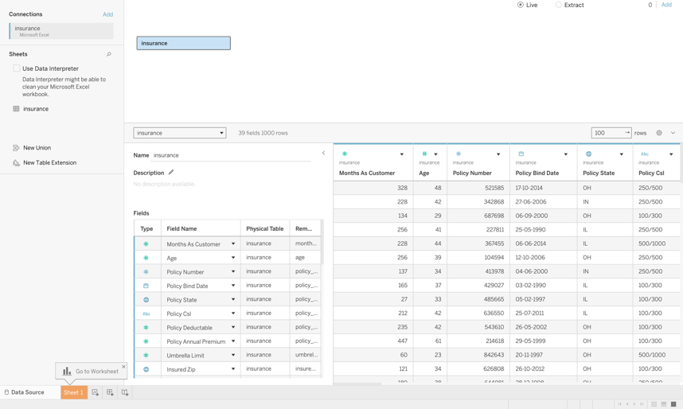
- 3> Step 6: Open Worksheet -> The data is now available for analysis.

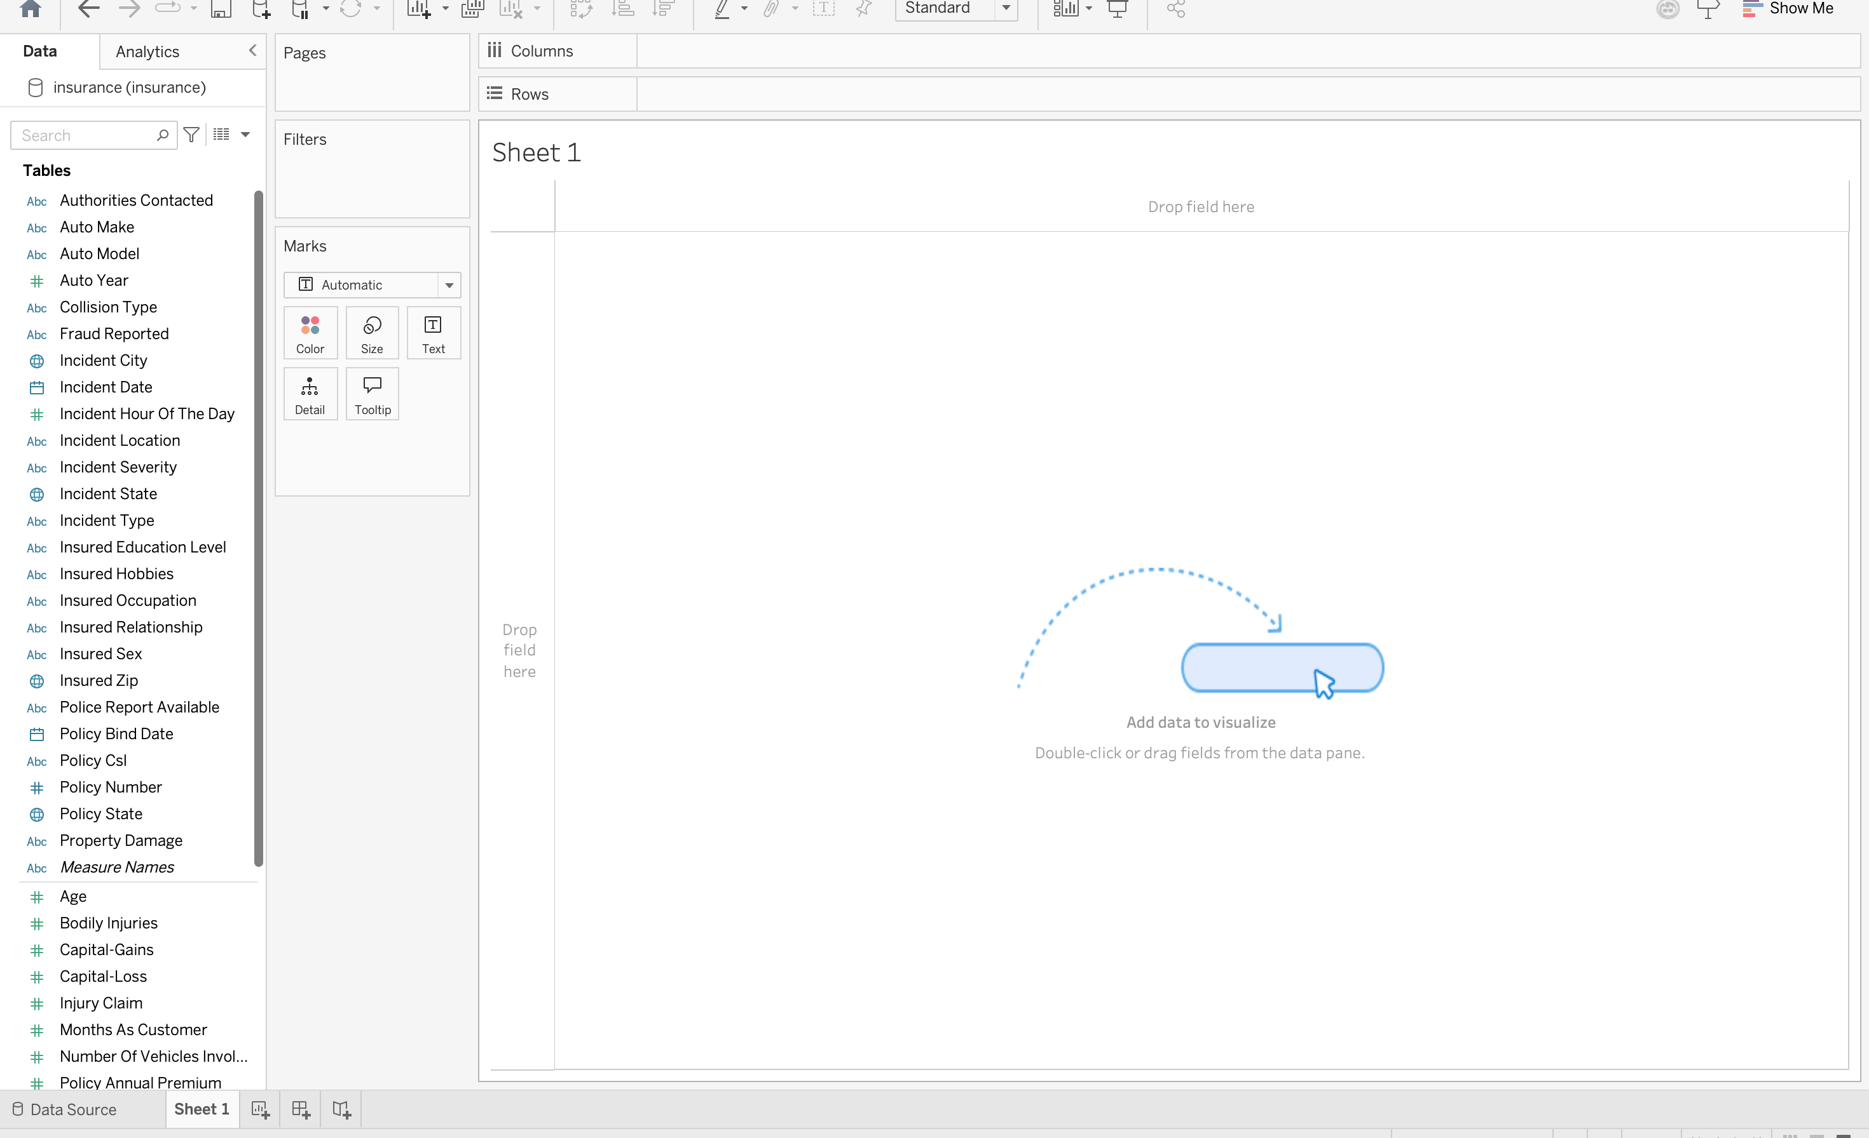

Connecting Tableau to a CSV File

Step 1: Open Tableau Desktop -> Select Text File-> Select CSV File-> Verify Imported Data
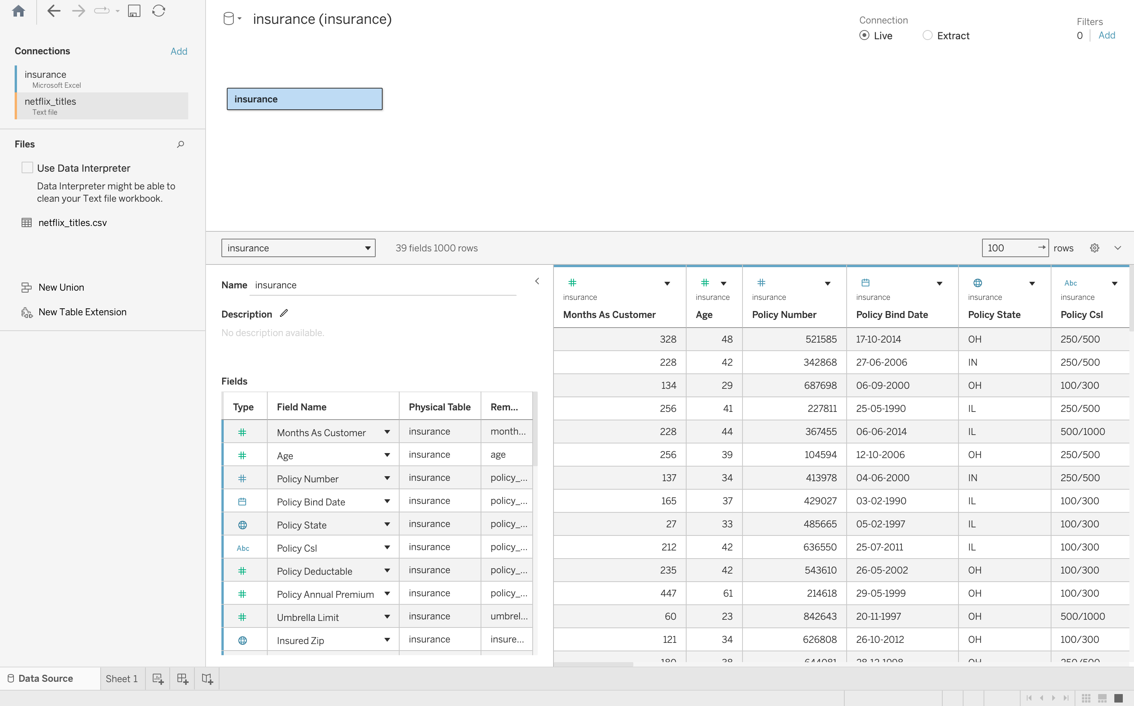
Step 2: Open Worksheet
